Total Quality Management (TQM)

Name
Course
Institution of Affiliation
Professor
Date

Total Quality Management (TQM)
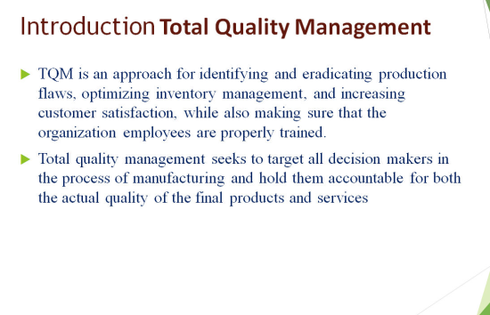
TQM is an approach to identifying and eradicating production flaws, optimizing inventory management, and increasing customer satisfaction while also ensuring that the organization's employees are properly trained. Total quality management seeks to target all decision-makers in the process of manufacturing and hold them accountable for both the actual quality of the final products and services.
Total quality management seeks to target all decision-makers in the process of manufacturing and hold them accountable for both the actual quality of the final products and services. TQM originated in the industrial sector, but its concepts can be applied to a wide range of industries. It provides a unified vision for structural reforms by emphasizing long-term transformation rather than short-term objectives. With that in mind, TQM is used in various industries, including manufacturing, healthcare, and financial services, to name a few, as well as businesses like ours (John, 2020).
These practices can be applied across the board at this corporation. This guarantees that employees are working toward the company's objectives, resulting in improved performance across the board. Some of the departments that may be involved are management, sales, manufacturing, and training staff.
Steps of managing Implementation of TQM
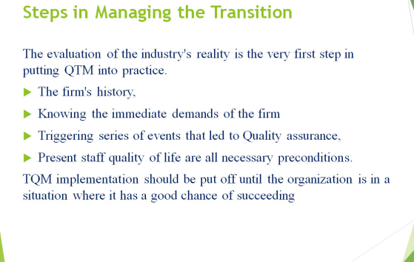
The evaluation of the industry's reality is the very first step in putting TQM into practice. The firm's history, immediate demands, triggering a series of events that led to Quality assurance, and present staff quality of life are all necessary preconditions. TQM implementation should be put off until the organization is in a situation where it has a good chance of succeeding.
TQM will be easier to implement if a corporation has a history of environmental awareness and the capacity to switch how it operates when necessary. When an organization has a record of becoming opportunistic and missing in the capacity to increase its management system, this would result in staff distrust and a scarcity of qualified top management. If the current situation does not improve, a comprehensive management development project may be put in place. Process management is a useful tool for identifying current elements of system performance as well as areas that need to be improved. A business ought to be in excellent shape before implementing TQM. Suppose there are significant challenges, for instance a extremely unpredictable financial foundation, inadequate administrative functions, a lack of leadership expertise, or low employee morale. In that case, Quality management systems will not be reasonable.
Steps in Managing the Transition
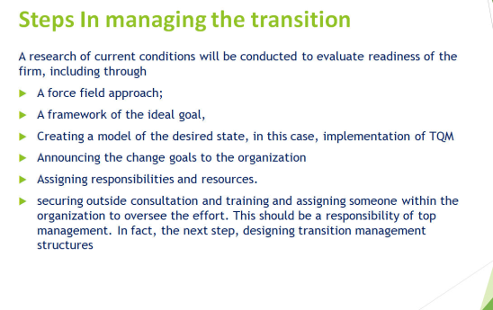
Research of current conditions will be conducted to evaluate the readiness of the firm, including through a force field approach; a framework of the ideal goal, in this particular instance, TQM execution, would be created; the change objectives would be announced to the company, and obligations and assets would be assigned. Securing external consulting and coaching and appointing someone inside the business to lead the project would be the final stage (Lucid, 2021). Senior executives should be in charge of all this implementation. In fact, the high level management is also in charge of every step, which is to build a transition organizational structure.
Keep in mind that the process is a challenging, extensive, and lengthy process. Leaders must remain committed, keep the system noticeable, facilitate adequate assistance, and hold everyone accountable for their actions. As much investor input as conceivable; as well as maximize staff participation in the system's layout. Always remember that TQM must be influenced by a specific goal. Keep the company's future vision in mind and actually focus upon that.
Customer’s Benefits from TQM
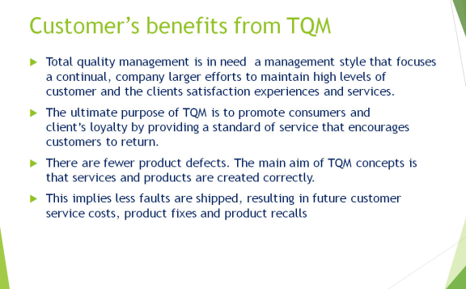
Total quality management needs a management style that focuses on continual, company larger efforts to maintain high levels of customer and the clients' satisfaction experiences and services. The ultimate purpose of TQM is to promote consumers and clients' loyalty by providing a standard of service that encourages customers to return. There are fewer product defects. The main aim of TQM concepts is that services and products are created correctly. This implies fewer faults are shipped, resulting in future customer service costs, product fixes and product recalls.
Low-Cost Strategy
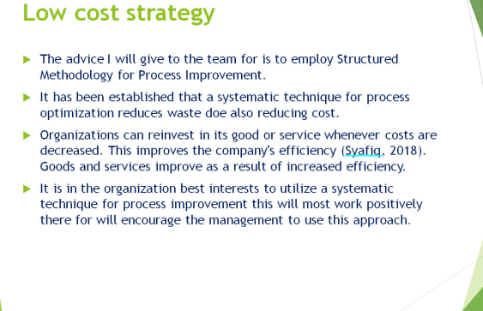
The advice I will give to the team for is to employ a Structured Methodology for Process Improvement. It has been established that a systematic technique for process optimization reduces waste doe also reducing cost. Organizations can reinvest in its good or service whenever costs are decreased. This improves the company's efficiency (Syafiq, 2018). Goods and services improve as a result of increased efficiency. It is in the organization's best interests to utilize a systematic technique for process improvement. This will most work positively there for will encourage the management to use this approach.
Conclusion
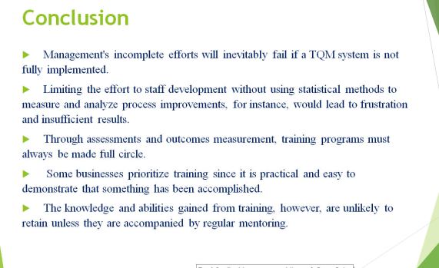
Management's incomplete efforts will inevitably fail if a TQM system is not fully implemented. Limiting the effort to staff development without using statistical methods to measure and analyze process improvements, for instance, would lead to frustration and unsatisfactory results. Through assessments and outcomes measurement, training programs must always be made a full circle. Some businesses prioritize training since it is practical and easy to demonstrate that something has been accomplished. However, the knowledge and abilities gained from training are unlikely to retain unless they are accompanied by regular mentoring.

References
John S, (2020). Productivity and Total Quality Management. Retrieved from https://courses.lumenlearning.com/suny-opmanagement/chapter/4-1-productivity-and-total-quality-management/
Lucid C, (2021). 8 Total Quality Management Principles to Improve Processes. Retrieved from https://www.lucidchart.com/blog/8-total-quality-management-principles
Syafiq H, (2018). How Quality Management Can Reduce Manufacturing Costs. Retrieved from https://www.linkedin.com/pulse/how-quality-management-can-reduce-manufacturing-costs-zahir/

